Acceptance Tests: To perform the tests, logging in and acting like a user of the system as specified in user stories were conducted.

Story 26; Report Issues acceptance criteria is fulfilled because visitors report health and safety issues by clicking on a link that takes them to a health and safety form to fill out and submit.

Story 8; Parking Permit Status acceptance criteria is fulfilled because parking permit status and information can be viewed on the profile and the permit can be update by simply pressing the update permit button.

\*Users click on report it link to report health issues.

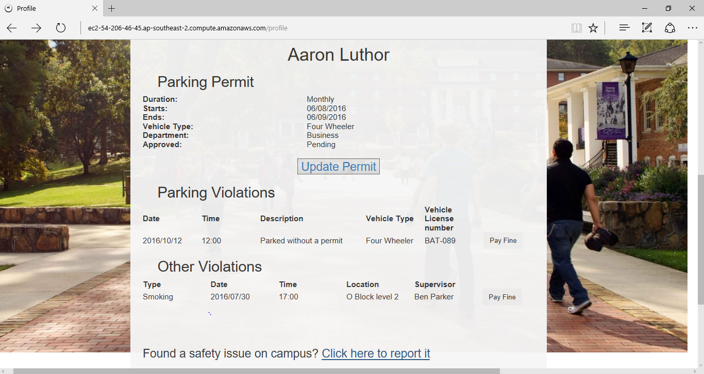

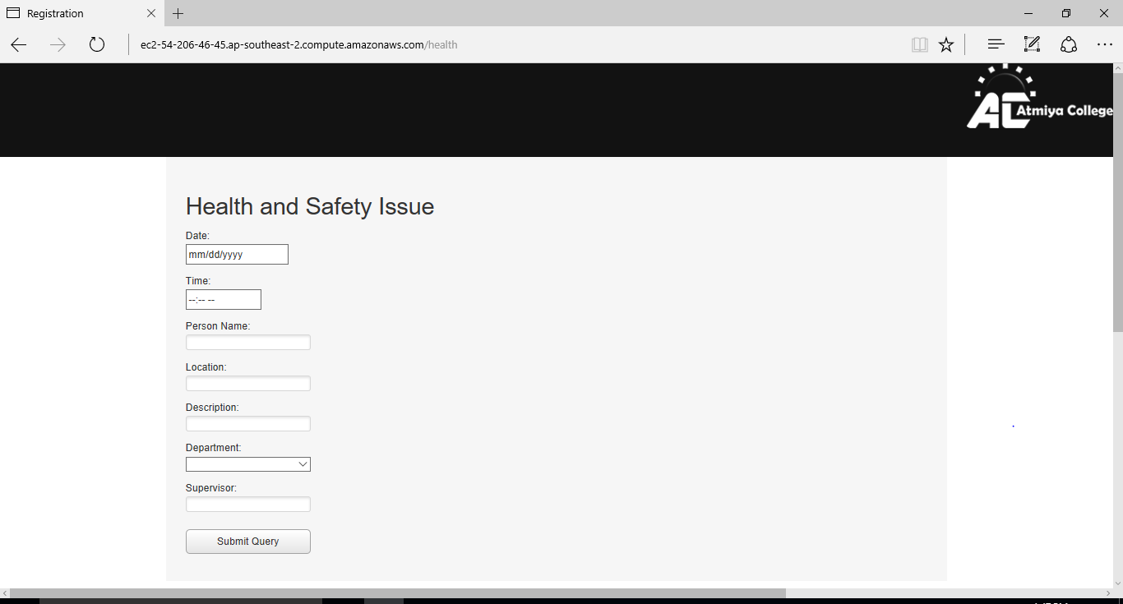Then users fill out the form and submit it.

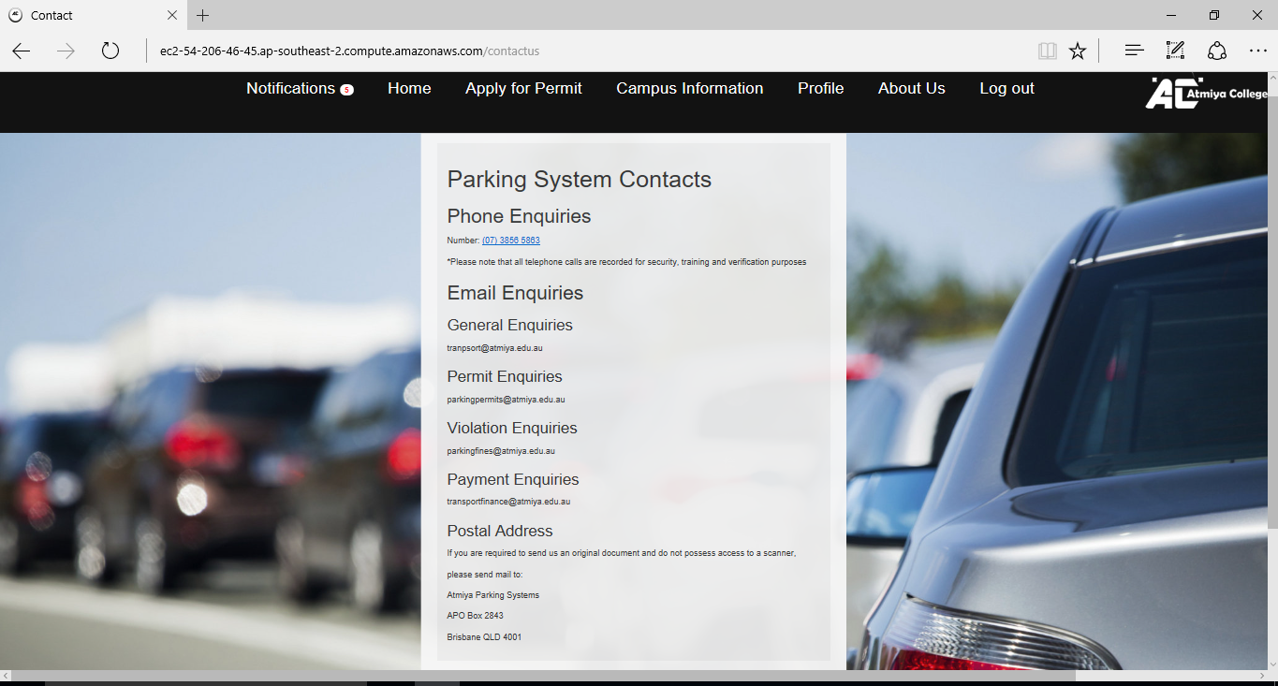Story 2 Visitor Parking Permits is fulfilled because visitors click on About Us and Contact Us and they contact the department about parking permits and any other services/products.

Story 7 Health form error checking is fulfilled because visitors cannot submit health violation form successfully if they are incorrect.

\*An incomplete/incorrectly filled out form.

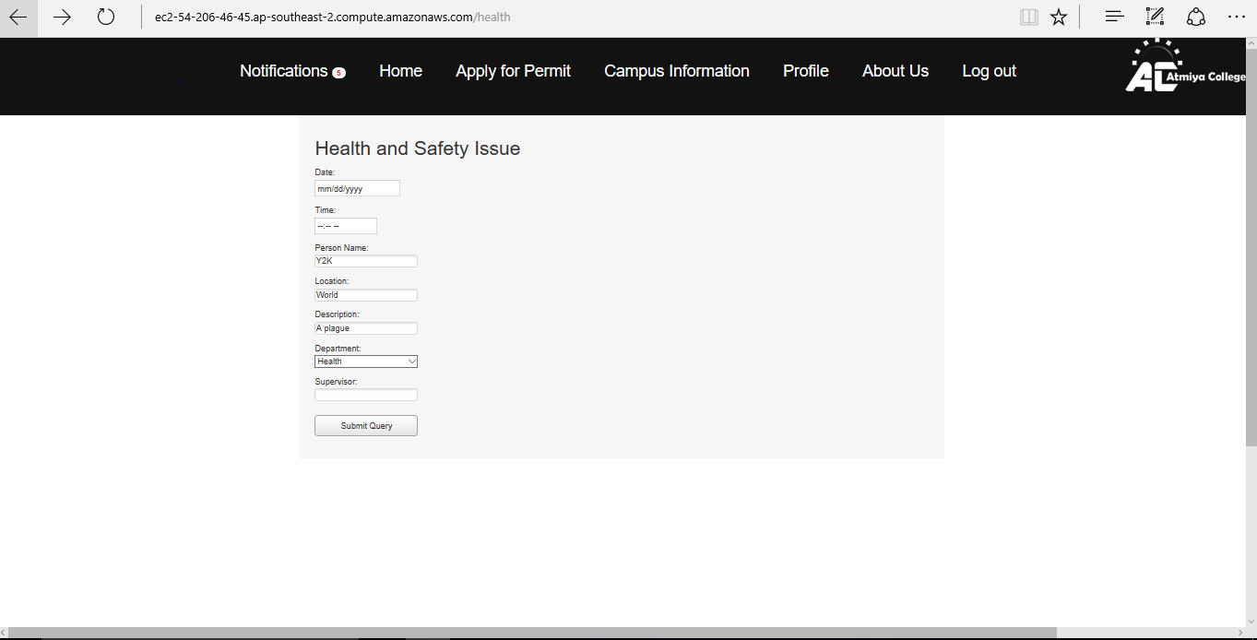

Story 24 Content Manipulation acceptance criteria is fulfilled because they able to make changes to content. Examples include able of changing and updating rules and health and safety notifications.

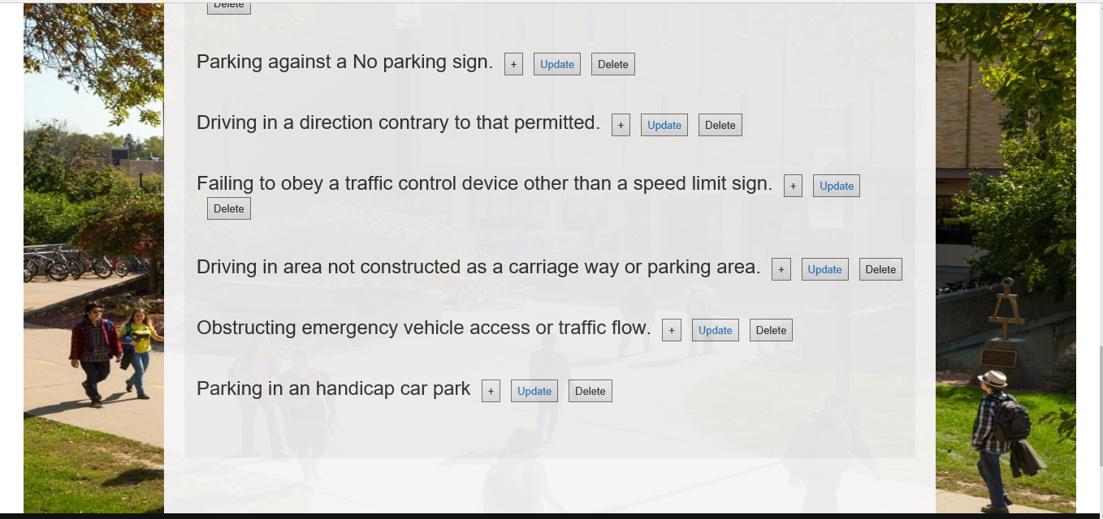

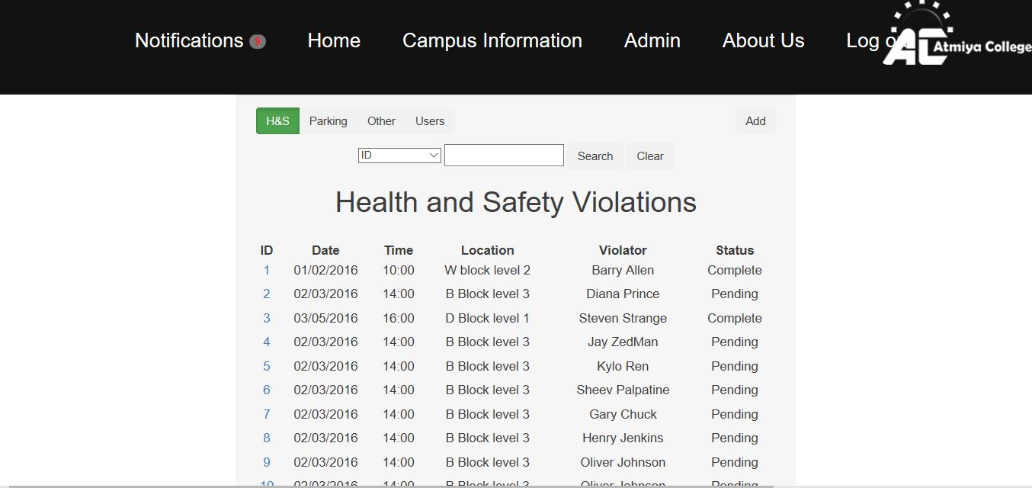

Story 18 Interface Design is complete because all information of parking permits and health violations can be found on the user’s profile.

Story 20 Review Report is complete because violators can review fine and parking violation information on their profile.

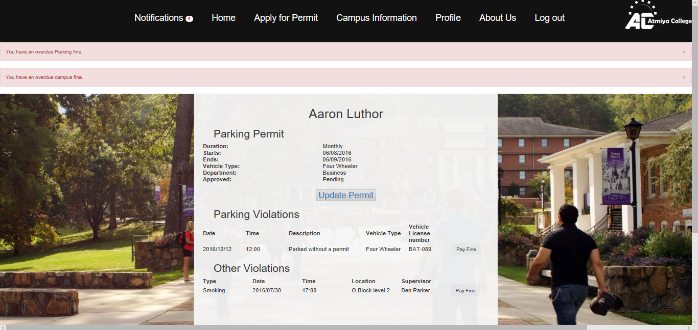

Story 27, Real-time Reports, has been fulfilled because admin can review health and safety violations including violations sent by users and they have options including delete/clear them.



Story 15 Violation Submission is complete because patrol officers to submit violations by filling out a citation report and specifies whether the violator has a permit or not and will be sen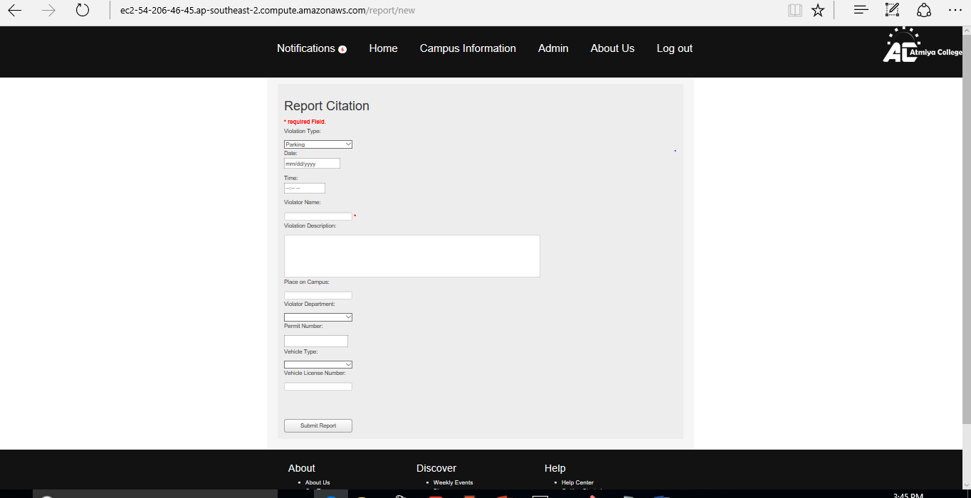t into the database after it is filled out and sent.

Story 4 Parking Permits is fulfilled because users can apply for permits and fill out the form with form checking parameters prevent invalid and incomplete forms are not sent and users are notified what they can fix.

\*Bob clicks on “Apply for Permit”

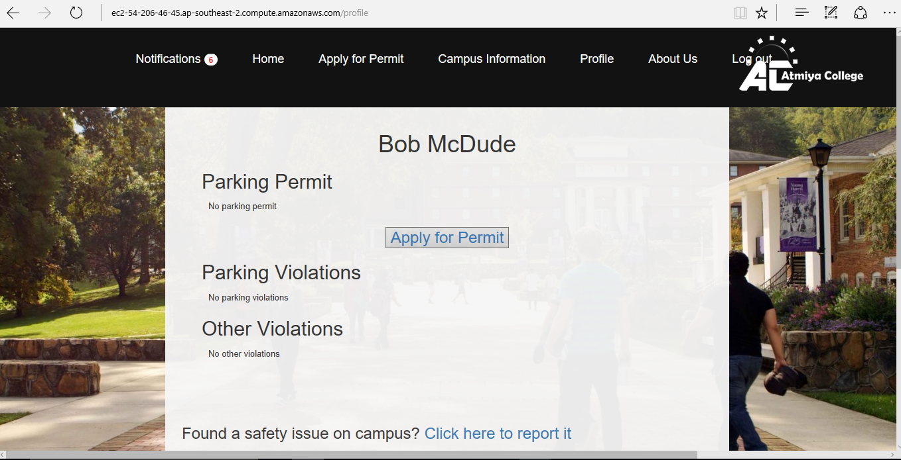

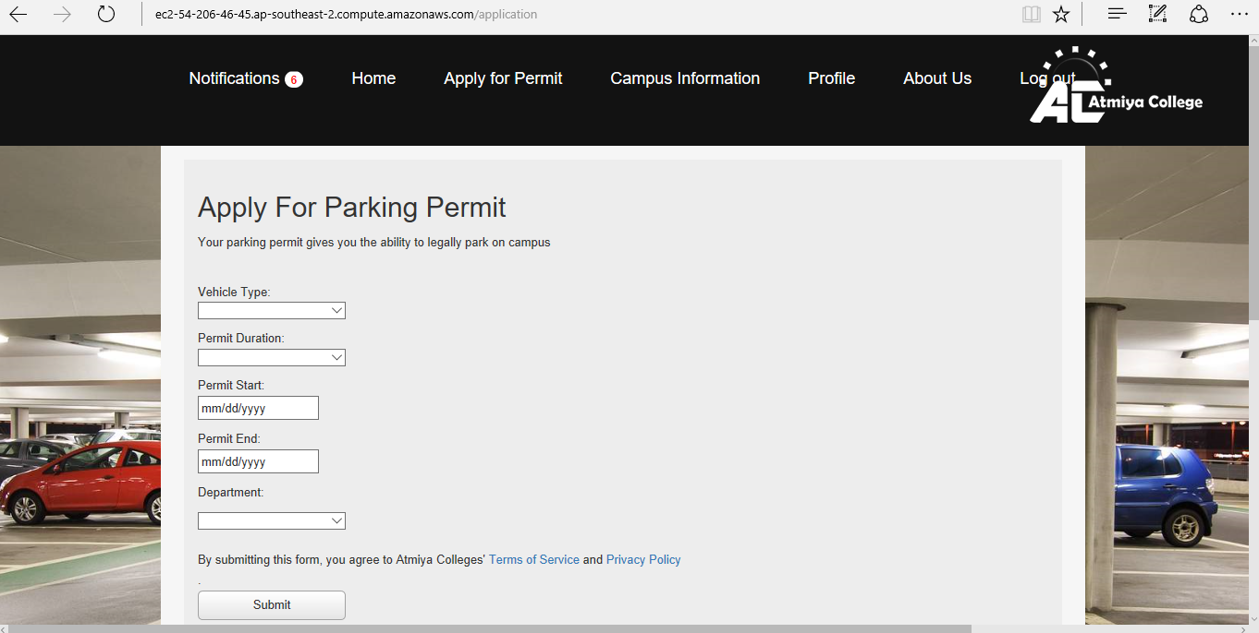\*Bob the fills our parking permit form.

Story 3 Citation form checking is complete because there form checking parameters that ensure forms cannot be sent unless it is complete and valid and they will inform users with details of why the form is incomplete and how to fix it if it is filled incorrectly.



Story 21 Information security is done because are encrypted and not stored in plain text, financial information is not saved.